**Importer/Exporter Businesses and their association:**

**Business Registered by:**

1. OwnerOne 🡪 BizOne
2. OwnerTwo 🡪 BizTwo
3. OwnerThree 🡪 BizThree
4. OwnerFour 🡪 BizFour

**Association Request sends by:**

1. OwnerOne 🡪 BizFour
2. OwnerThree 🡪 BizOne,BizTwo
3. OwnerFour 🡪 BizTwo

**Business Association with User:**

1. BizOne 🡪 OwnerOne

* OwnerThree

1. BizTwo 🡪 OwnerTwo

* OwnerThree
* OwnerFour

1. BizThree 🡪 OwnerThree
2. BizOne 🡪 OwnerOne

* OwnerFive

**User Associated with businesses:**

1. OwnerOne 🡪 BizOne

* BizFour

1. OwnerTwo 🡪 BizTwo

1. OwnerThree🡪 BizOne

* BizTwo
* BizFour

**Business Details:**

OwnerOne:

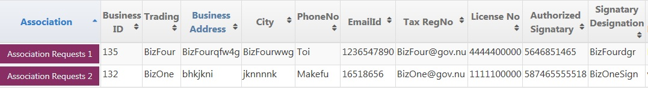

1. Association Request – BizFour(Business Id- 135)

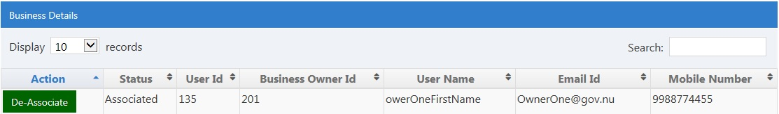

1. Association Request – BizOne(Business ID- 132)

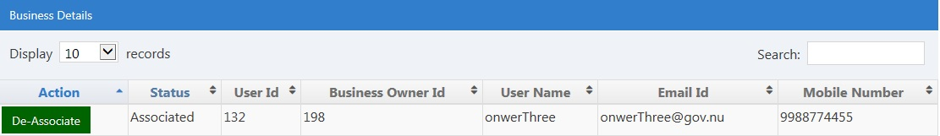

**For importer/Exporter- OwnerOne (own business-BizOne)**

* Send association request to BizFour(OwnerFour)
* Send association request to ABizFour(AgentTwo)
* OwnerThree send association request to BizOne(OwnerOne)
* AgentOne send association request to BizOne(OwnerOne)
* AgentTwo send association request to BizOne(OwnerOne)
* AgentThree send association request to BizOne(OwnerOne)
  1. **OwnerOne** can Associate/Deassociate request for Business **BizFour** where user OwnerOne and AgentFour associated, Because
     1. OwnerOne associate to BizFour
     2. OwnerFour is owner of BizFour
  2. **OwnerOne** can Associate/Deassociate request for Business **ABizTwo** where user AgentThree, OwnerOne and OwnerThree associated, Because
     1. OwnerOne associate to ABizTwo,
     2. OwnerThree associate to ABizTwo
     3. AgentThree associated to ABizTwo.
  3. **OwnerOne** can Associate/Deassociate request for Business **BizOne** where user OnwerThree, AgentThree, AgentTwo and AgentOne associated, Because
     1. OnwerThree associate to BizOne,
     2. AgentThree associate to BizOne,
     3. AgentTwo associate to BizOne,
     4. AgentOne associate to BizOne,
     5. **BizOne** is owner of BizOne.

**For Agent – AgentOne (Own business- ABizOne)**

* Send association request to ABizOne(AgentOne)
* OwnerTwo send association request to ABizOne(AgentOne)
* OwnerThree send association request to ABizOne(AgentOne)
* OwnerFour send association request to ABizOne(AgentOne)
* AgentTwo send association request to ABizOne(AgentOne)
* AgentThree send association request to ABizOne(AgentOne)
  1. **AgentOne** can Associate/Deassociate request for Business **ABizOne** where user AgentTwo, AgentThree, OwnerTwo, OwnerThree and OwnerFour associated, Because
     1. OwnerTwo associate to ABizOne
     2. OwnerThree associate to ABizOne
     3. OwnerFour associate to ABizOne
     4. AgentOne associate to ABizOne
     5. AgentTwo associate to ABizOne
     6. **AgentOne** is owner of ABizFour
  2. **AgentOne** can Associate/Deassociate request for Business **BizOne** where user AgentThree, AgentTwo, AgentOne and onwerThree associated, Because
     1. AgentThree associate to BizOne
     2. AgentTwo associate to BizOne
     3. AgentOne associate to BizOne
     4. onwerThree associate to BizOne

**for Associate Agent Request (My customer):**

* **AgentFour** associate Business:
* Customer Biz Name: **BizFour**
* Agent Biz: **ABizFour**
  1. **Agentfour** can Associate/Deassociate Request for Agent **BizFour**
  2. **OwnerFour** can only see for Agent **BizFour**